Project Design Phase
Solution Architecture

Date | 25 June 2026
Team ID
Project Name | An employee requests installation of licensed software through the Service Catalog
Maximum Marks | 4 Marks

Solution Architecture:
- The solution is built on the ServiceNow platform to automate software installation requests.
- Employees submit requests through the Service Catalog with required software details.
- Catalog Variables capture information such as software name, version, license type, and business justification.
- Flow Designer and Workflows automate approvals, task creation, and request fulfillment.
- Business Rules automatically create incidents when licensed software is unavailable.
- Request data is stored in sc_request, sc_req_item, sc_task, and incident tables for tracking.
Example - Solution Architecture Diagram:
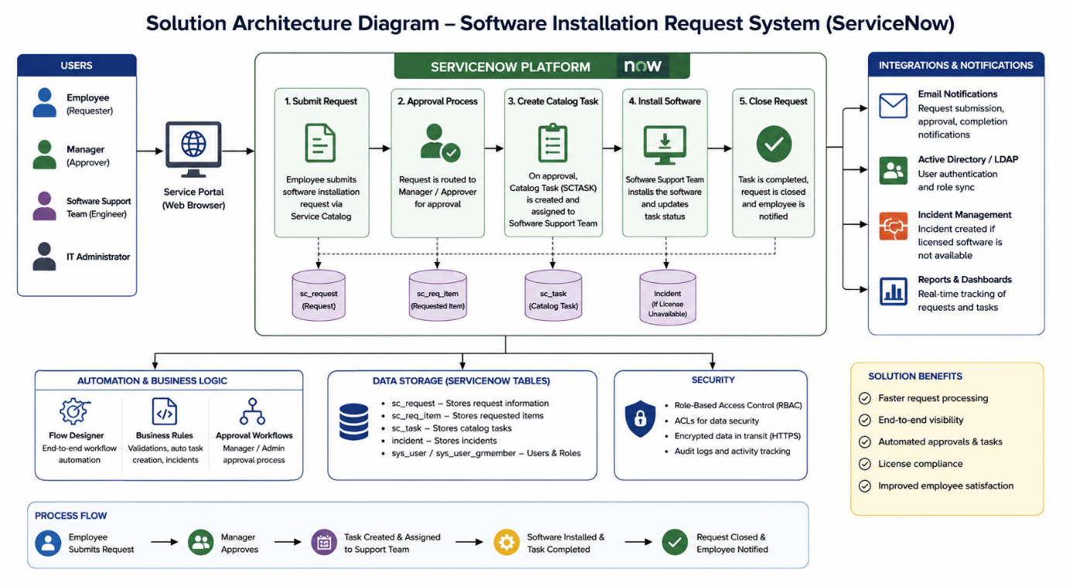

Figure 1: Software Installation Request System
Reference: https://aws.amazon.com/blogs/industries/voice-applications-in-clinical-research-powered-by-ai-on-aws-part-1-architecture-and-design-considerations/

